ASSIGNMENT-7 AIPP

Name:SYEDA AFIFA FATHIMA
Roll No:-2503b05142
Branch:-CSE(M.TECH)

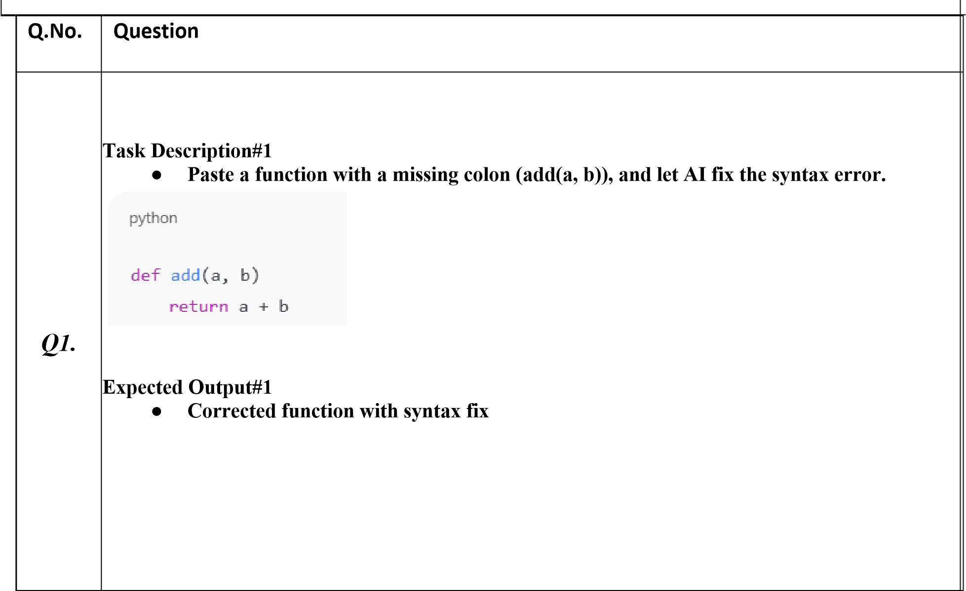
Q2. | 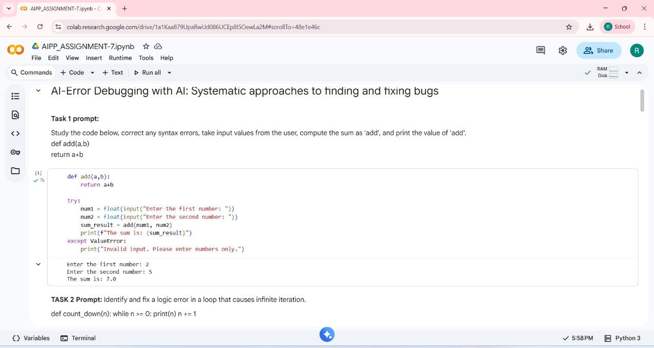  Task Description#2 (Loops)  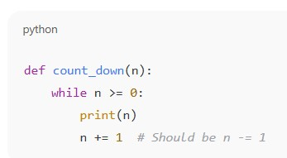  - Identify and fix a logic error in a loop that causes infinite iteration.  Expected Output#2  - AI fixes increment/decrement error  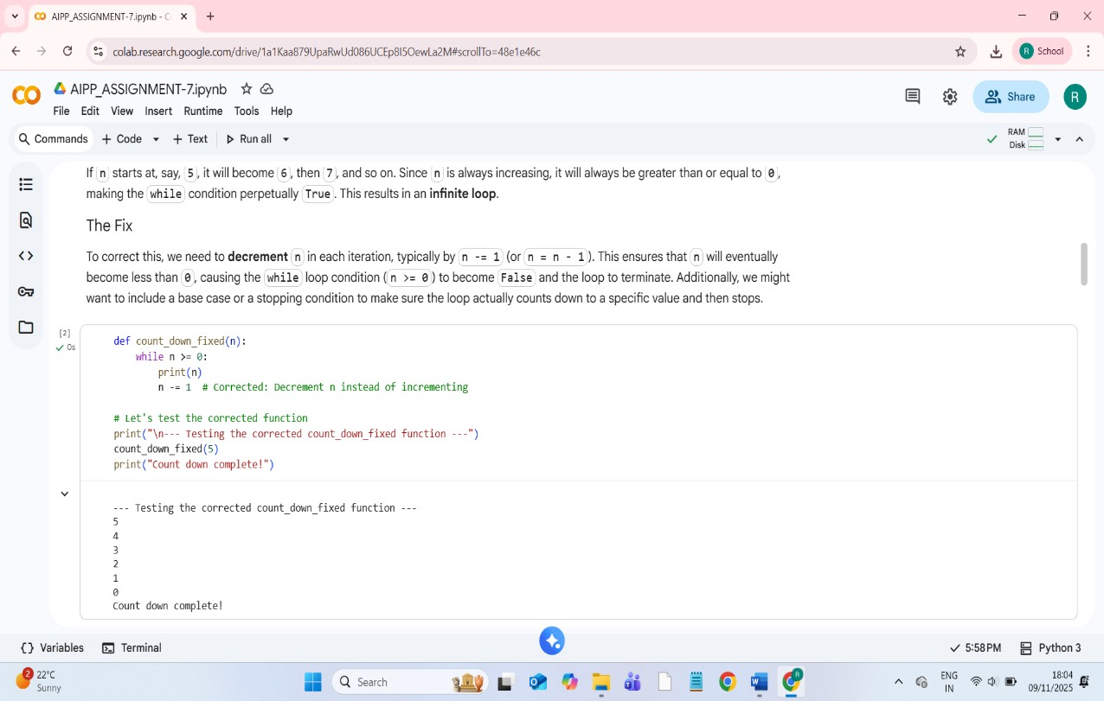

Q3.  Q4 | Task Description#3  - Debug a runtime error caused by division by zero. Let AI insert try-except.  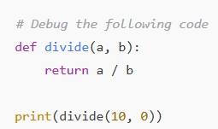  Expected Output#3  - Corrected function with safe error handling  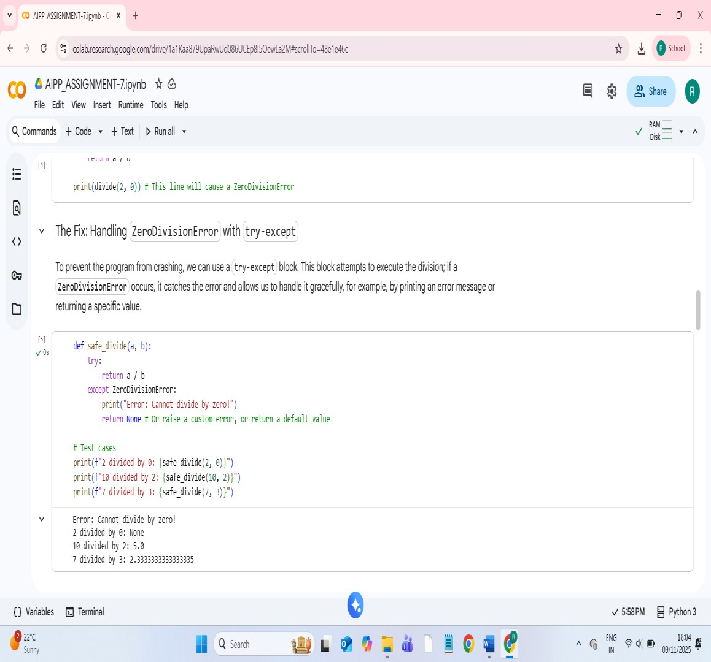  Task Description#4  - Provide a faulty class definition (missing self in parameters). Let AI fix it  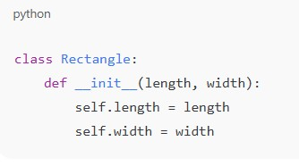  Expected Output#4  - Correct __init__() method and explanation

Q5. | 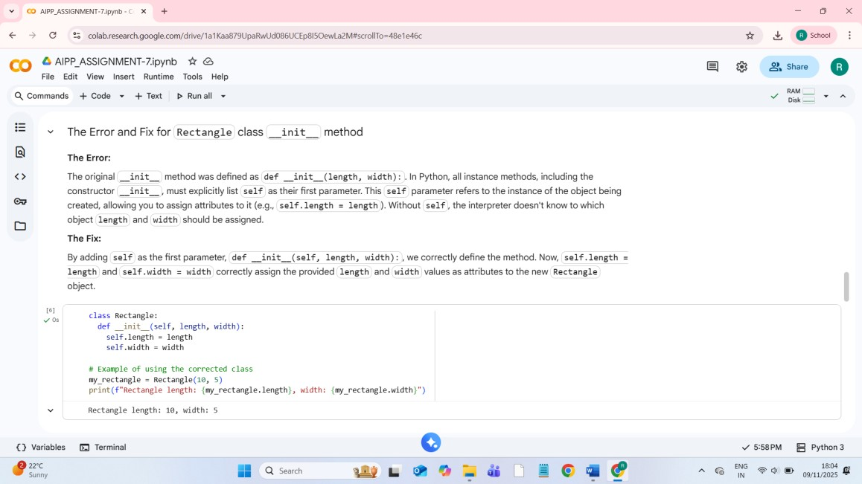  Task Description#5  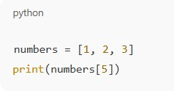  - Access an invalid list index and use AI to resolve the Index Error.  Expected Output#5  - AI suggests checking length or using safe access logic  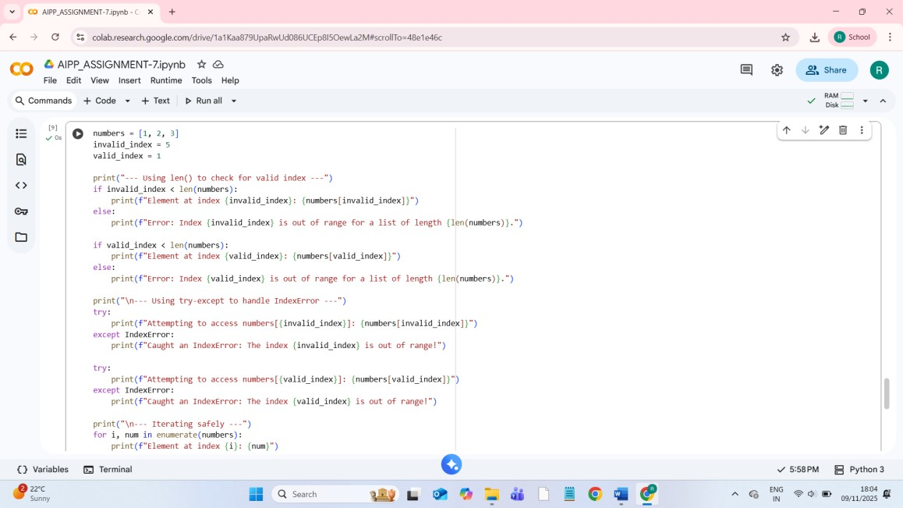
 | 